Name: ___________________________________________________ Date: _____________________

AP Calculus AB: Unit 7 Day 5 HW Visca

In Exercises 7–10, find the volume of the solid generated by revolving the shaded region about the given axis.

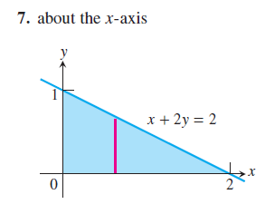

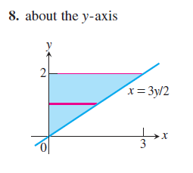

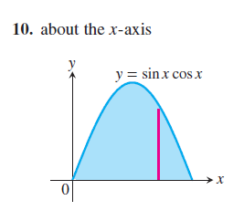

In Exercises 11–20, find the volume of the solid generated by revolving the region bounded by the lines and curves about the *x*-axis.







In Exercises 23–28, find the volume of the solid generated by revolving the region about the *y*-axis.





